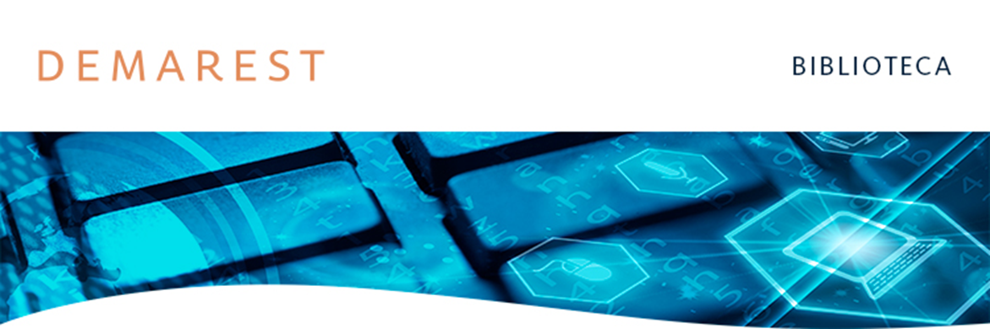

Na Mídia
15/07/2025 | The Latin American Lawyer

Demarest advise on the CRA issuance backed by Pantanal

Demarest Advogados advised on the public offering of agribusiness receivables certificates (CRA), corresponding to the 386th issuance by Eco Securitizadora de Direitos Creditórios do Agronegócio, backed by agribusiness receivables owed by Pantanal.
The issuance under the automatic registration procedure in accordance with CVM Resolution No. 60, CVM Resolution No. 160, and other applicable legal and regulatory provisions.
Demarest advised Pantanal Agrícola, Banco Santander (Brasil), Itaú BBA Assessoria Financeira, Banco Bradesco BBI, and Banco Votorantim and relied on partner Luiz Felipe Eustaquio (pictured), associates Bruno Alderighi Cavalcanti, Lucas Schiavon, Paola Liberman

